Date: 27-05-2026

Assignment 5: Summary report - Conditional Highlighting

How to use conditional highlighting in the summary report. By default, it is not visible that we have to do something to activate/enable conditional highlighting in summary reports.

Step 1: Go to Classic View
Step 2: Select Reports Object

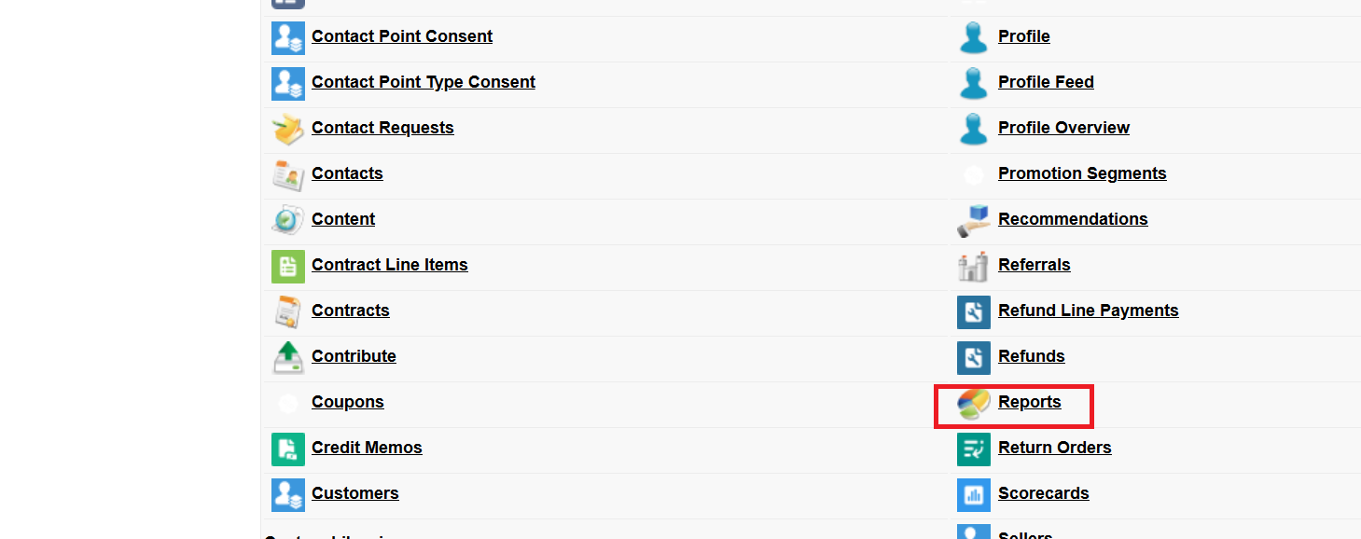

Step 3: Click on the New Report Button
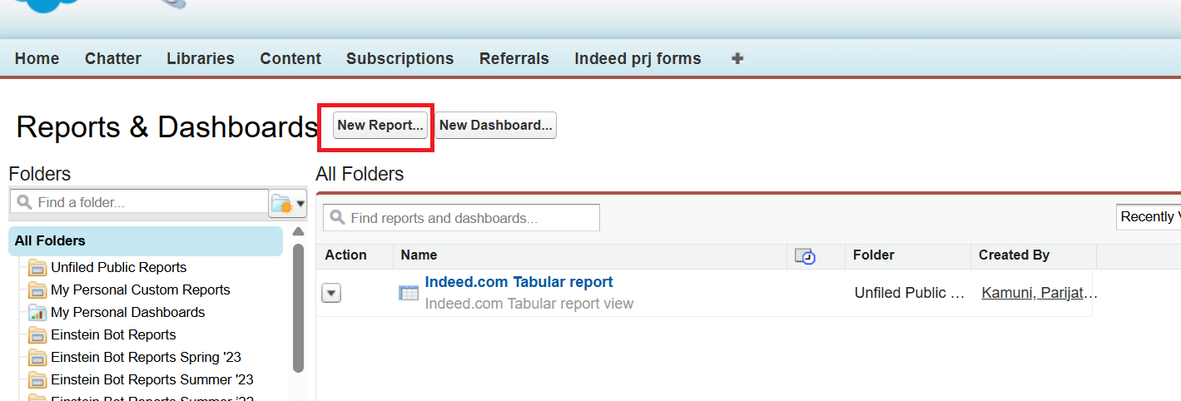

Step 4: Expand Other Reports for Custom Object
Step 5: Select the Custom Object (Indeed prj forms)
Step 6: Click on the Create Button

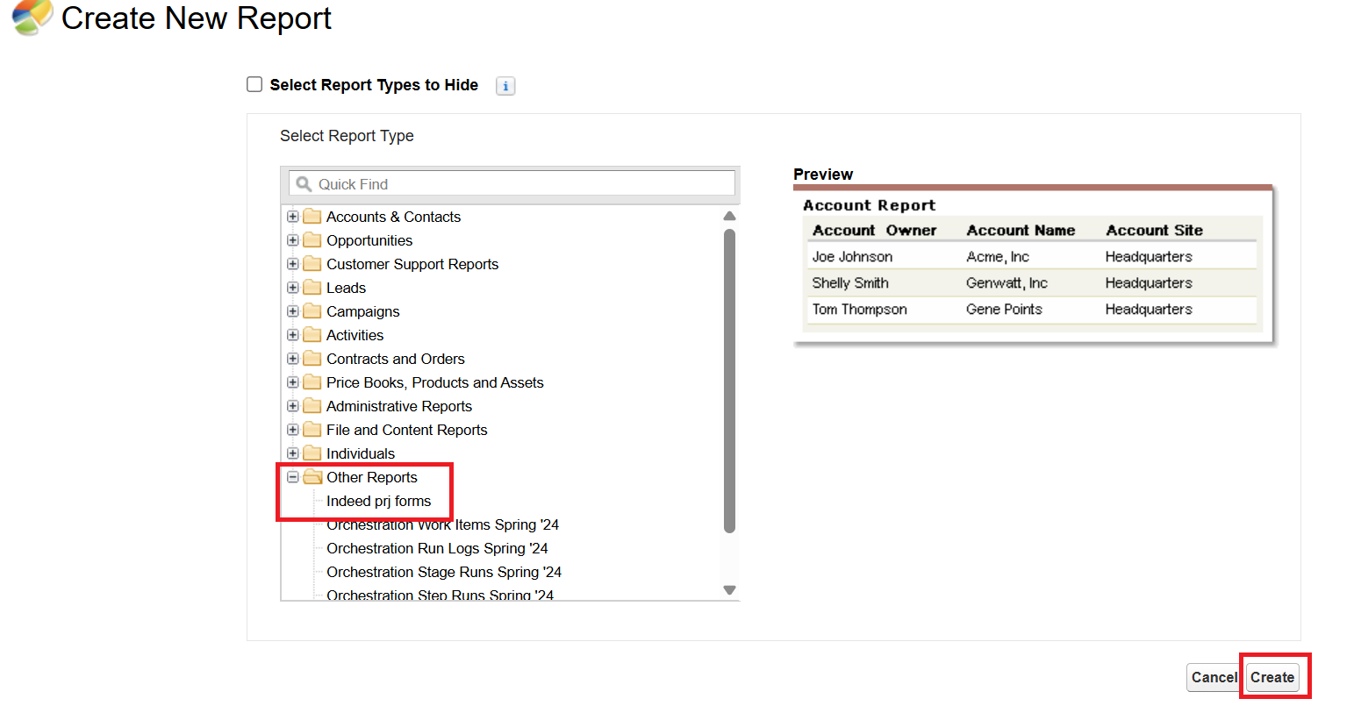

Step 7: Save the Report. Click on the Save Button
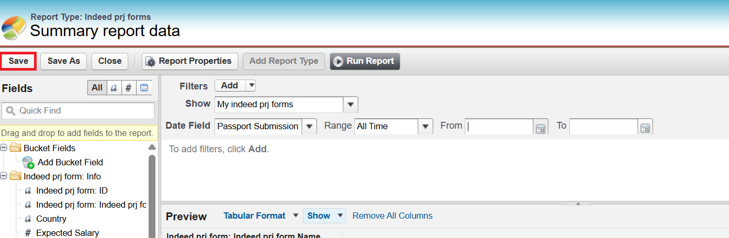

Step 8: Type the Report Name
Step 9: Unique Name will be auto-populated
Step 10: Enter Description
Step 11: Select Unfiled Public Reports
Step 12: Save the Report. Click on the Save Button

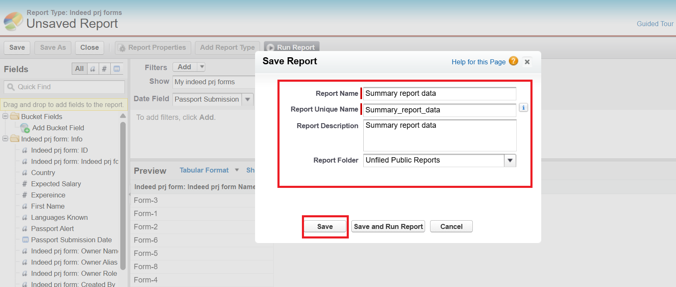

Step 13: Click on the Tabular Format Dropdown
Step 14: Select the Summary Report

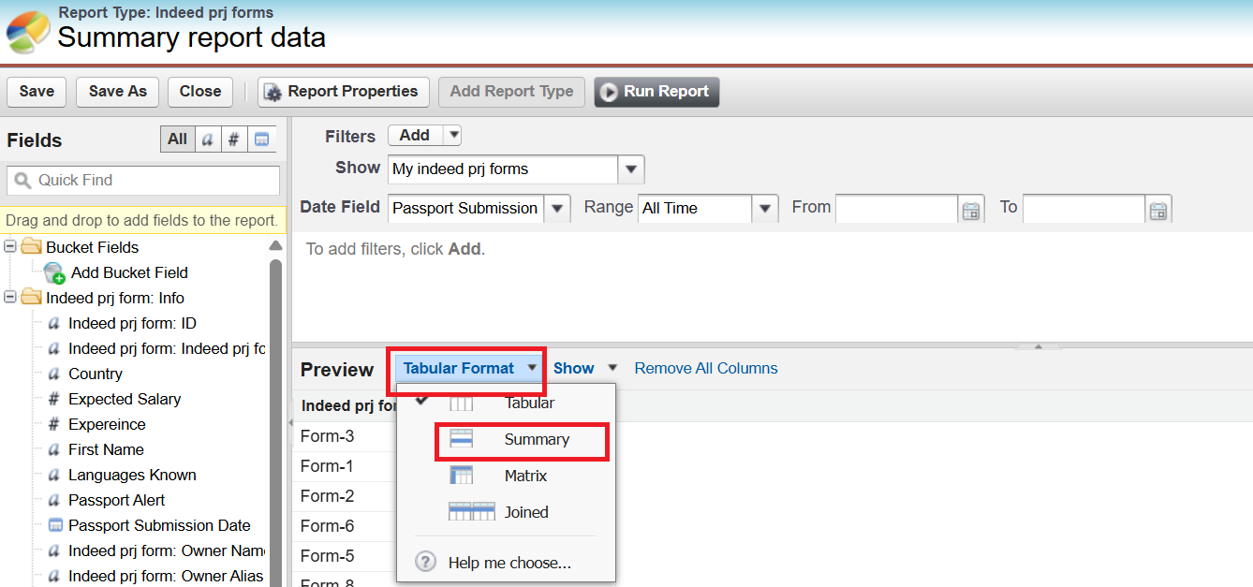

Step 15: Double-click the Fields you want to display in the report from the Left pane, and the field will be added. (Expected Salary, Experience, FirstName, Languages Known)
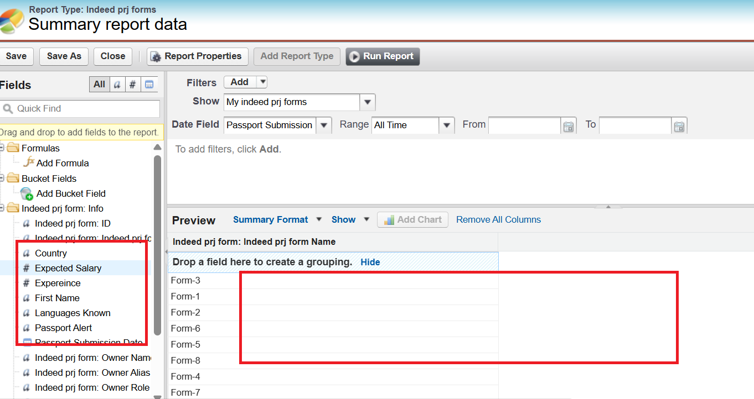

Step 16: Drag and drop the required field (Country Field) at the “Drop a field here to create a grouping” section for Grouping

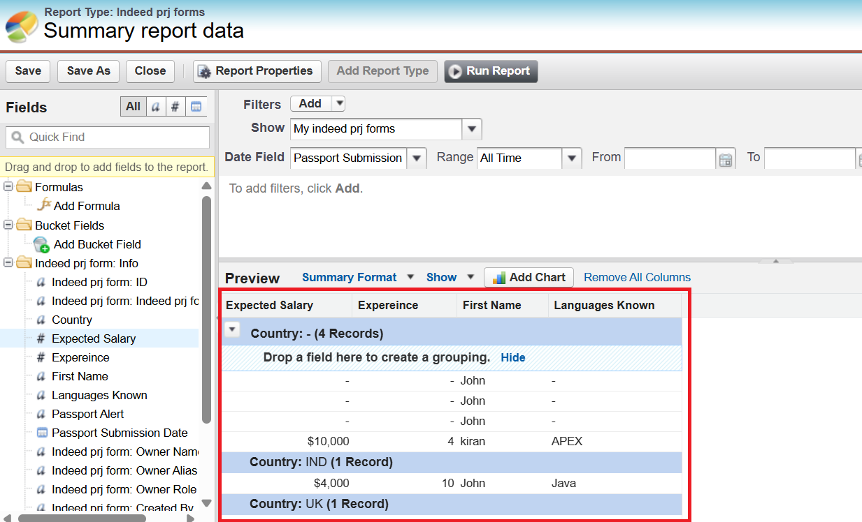

Step 17: Click on the Number Field (Conditional highlighting can be done for Number fields only). ADDING A SUMMARY FIELD IS MANDATORY TO ENABLE THE CONDITIONAL HIGHLIGHTING OPTION
(Conditional highlighting only works on summary values. If you don’t summarize a number field, the highlighting option won't appear.)

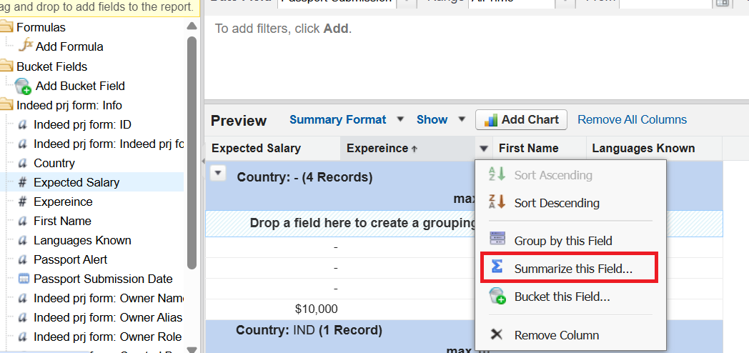

Step 18: Select the summary (SUM, AVG, MAX, MIN) and click on the Apply button. This is the field that will get the color highlighting.
You must have at least one summarized numeric field in the report, like SUM, AVERAGE, MIN, or MAX on a number field.
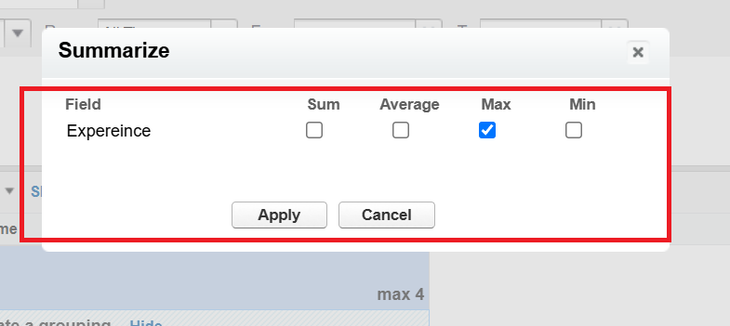

Step 19: Select Show Dropdown and Select Conditional Highlighting 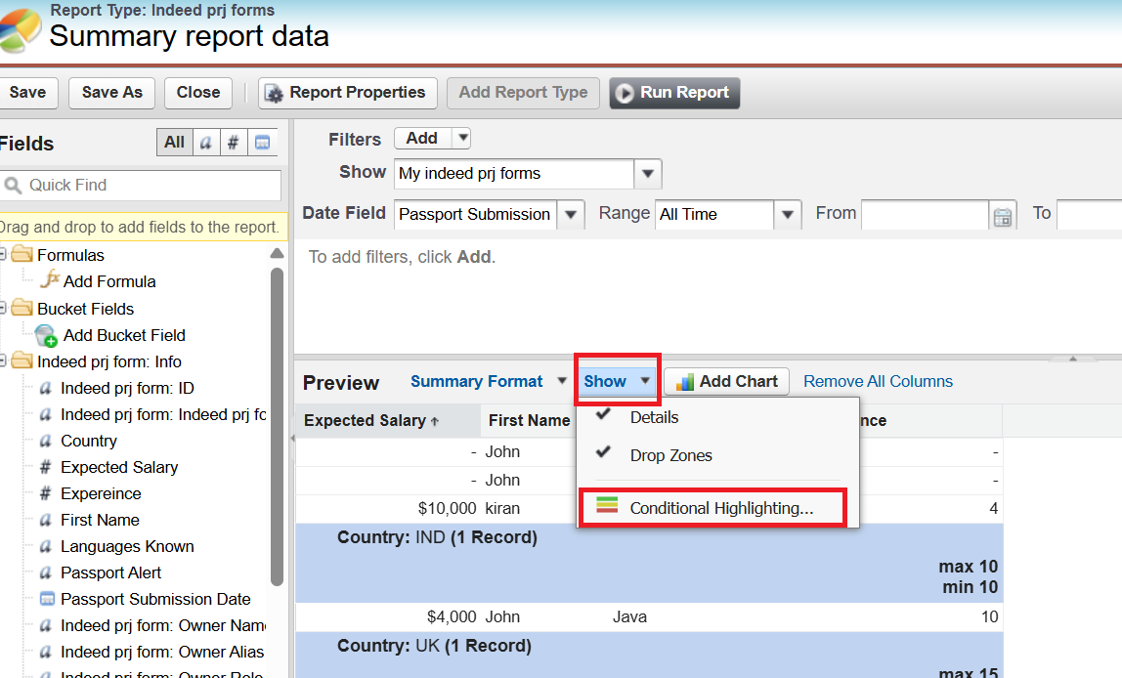

Step 20: Select the experience that you want to highlight, and also choose the conditions like Low, Medium, High, and pick the Colors to highlight

Step 21: Click on the OK Button

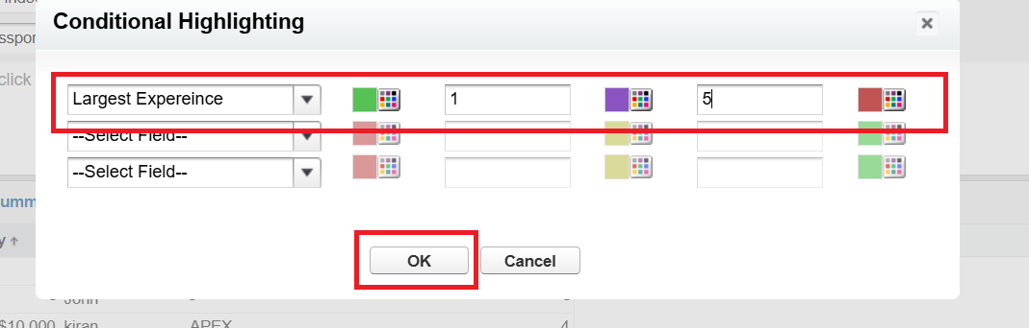

Step 22: Click on the Run Report Button to see the result, and click onthe Save Button

If Min Exp is 0 is Green color

If Exp is < 5 is Purple color

If Exp > 5 is Red Color

